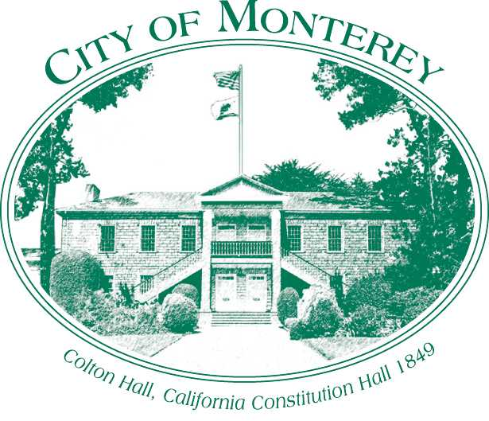

Measure X Project Report
December 2025

Measure X Transportation Projects
Del Monte and Casa Verde Recreational Trail Intersection Improvement Project
This project is using Measure X funding in combination with the Highway Safety Improvement Program and the Neighborhood and Community Improvement Program to enhance transportation safety.

Project Description
In August 2018, City staff applied for a competitive grant through the Highway Safety Improvement Program to fund intersection improvements at Del Monte and Casa Verde. The project was first identified as a part of a community planning process. During the public engagement effort, residents of the Del Monte Beach neighborhood had several concerns with the existing crossing and intersection. The project was initiated through the Neighborhood and Community Improvement Program (NCIP). The intersection of Del Monte and Casa Verde is the only entry point into the Del Monte Beach Neighborhood and Del Monte Beach. Following this initial feedback, additional review was completed and found this intersection to have a higher number of collisions.
Due to the unique characteristics and the trail crossing, the area surrounding Casa Verde shows a concentration of collisions. This intersection is the convergence point of a major neighborhood entrance, a heavily used trail crossing, and a major commute route into the city for all modes of transportation, especially bicycles, which utilize the Monterey Bay Coastal Recreational Trail. The Recreational Trail links the cities of Marina, Sand City, and Seaside to Monterey and Pacific Grove. The trail connects employment centers such as Cannery Row and Downtown to residential areas and is used throughout the day as well as evening hours. The project will provide safe access for bicyclists and pedestrians on a vital link between residential, commercial, educational, and community facilities. Design and construction improvements included in this project are trail and crosswalk improvements, traffic signal safety modifications to include protected left turns on Casa Verde and ADA improvements. Figure 1 shows an excerpt from the Project Plans.
This project provides great benefits and access for pedestrians and bicyclists for those who utilize the recreational trail for commuting and recreational purposes. The expected benefits include increased biking and walking trips to improve public health, enhanced mobility for non‐motorized users to be more widely accessible for users of all abilities, and reduced vehicle trips to reduce greenhouse gas emissions. All benefits apply to disadvantaged communities who utilize the trail to commute or for recreation purposes. The project provides access to major destinations in the City such as Monterey Downtown, The Wharf, Cannery Row, and El Estero Park.
The improvements would make the crossings at the two intersections less stressful for bicycles and pedestrians by shortening distances, providing median refuges and higher visibility. Additionally, ADA improvements and safety lighting are included.

Project Update
The Project Design was completed in Fall 2023, the project was bid in spring 2024 with construction expected to begin January 2025. The Construction Contract was executed in July 2024 and the project broke ground in February 2025. The project has incurred many delays including weather, groundwater issues, and material delays. As of December 2025, the project has minor corrective work, traffic striping and marking, and landscaping activities to complete the project. The City is waiting on a material shipment for corrective work that will arrive in February 2026. The project will likely be completed by March 2026 and the paperwork closed out in summer 2026.
Due to the delays, the City extended the Construction Management Contract with SJ Construction Management. This extension will be reflected in the 2026 report.

Project Funding

Design
Additional Design Services and Design services during construction $46,260

Construction
Highway Safety Improvement Program (HSIP) Grant (37N1214) $730,057.15
Measure X (35C1851) $226,045.35
Measure P-ADA (35C1555) $644,587.50
Construction Contract (Total Base Bid) $1,600,690.00
Construction Contingency, 15% $240,103.50
Total Project Construction Estimate $1,840,793.50

Construction Management
Highway Safety Improvement Program (HSIP) Grant (37N1214) $99,580.00
Measure X (35C1851) $134,209.37
Measure P-ADA (35C1555) $134,209.37
Total Construction Management $367,998.74

Before & After Photos
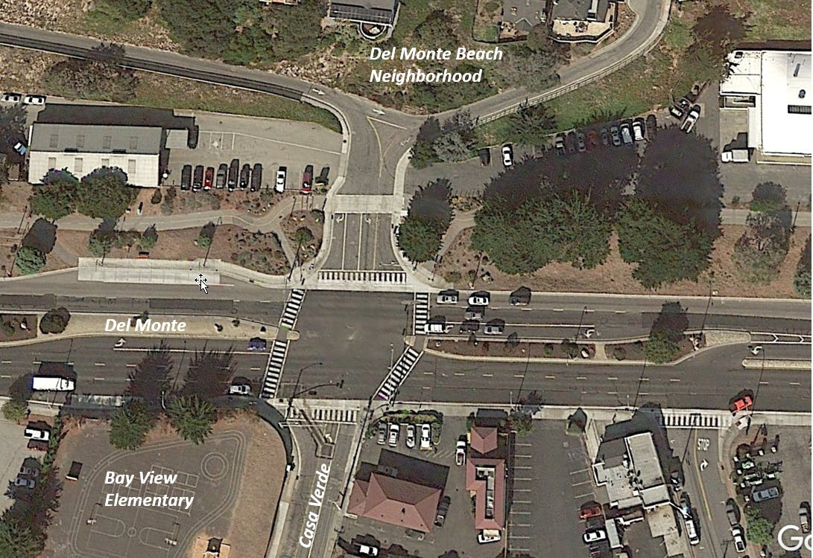
Before
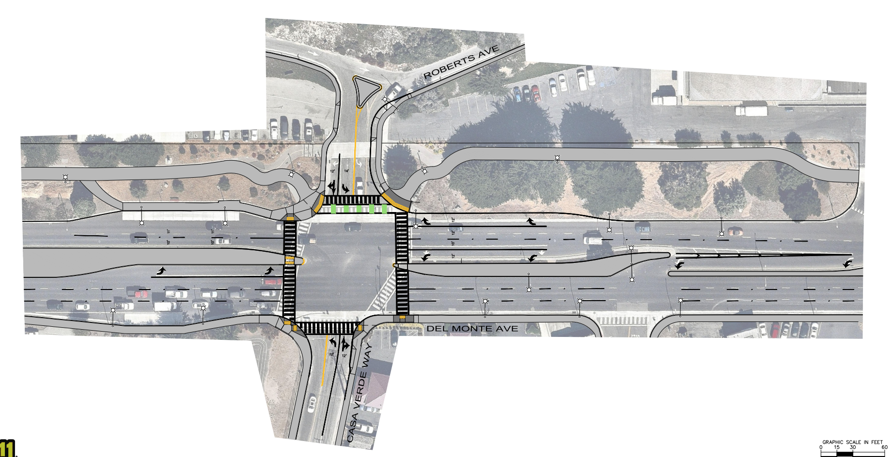Project Design

