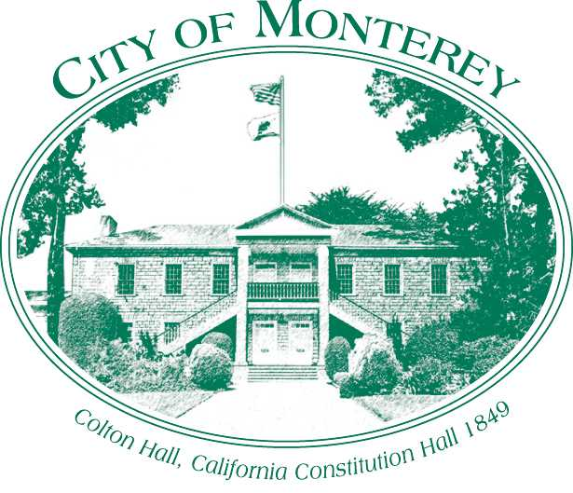

Measure X Project Report
December 2025
Measure X Transportation Projects
Calle Principal Multimodal Improvement Feasibility Study Bike & Ped Improvements
This project is the prime example of using Measure X funding to support transportation safety and active transportation improvements to enhance the quality of Transportation in Monterey and Monterey County.

Project Description
This project proposes bicycle improvements connecting downtown along Calle Principal. This connection would provide a bicycle connection to the Conference Center and eventually connect to the Pearl Street Bicycle Improvements in the Multimodal Plan.

Project Update
The City has prepared preliminary concepts and technical studies. Staff is working on adding this project to Move Monterey the City’s Multimodal Plan Project List including public outreach.

Project Funding
Account 1(35c1851) (MEASURE X): $20,030.00
Account 2 (CIP2615) (MEASURE X): $200,000.00
Total: $220,030.00

Photos
Preliminary Concepts
