

Measure X Project Report

December 2024

Measure X Transportation Projects

Citywide Post/Median Alert Installation Project

This project is the prime example of using Measure X funding to support transportation safety and operations improvements to enhance the quality of Transportation in Monterey and Monterey County.

## Project Description

PostAlert and MedianAlerts are identified as low cost and simple enhancements which can be attached to existing poles and medians to place emphasis on an important or partially obstructed sign. PostAlert and Median Alerts are impact and temperature-resistant High-Density Polyethylene (HDPE) substrate and premium micro-prismatic highly retroreflective sheeting. and cover beyond 180 degrees. They provide greater visibility during day and nighttime driving.

Multiple intersections have been identified through discussions with the Streets Maintenance Team, Engineering Team and Police Department to identify locations where the staff had received citizen complaints, frequent knock downs of signs, frequent citations or warnings by the Police Department. City Staff tested a few locations and then expanded the use when these locations were met with support from the public.

## Project Update

The Post Alerts and/or Median Alerts have been installed at just over 15 intersections. Staff has purchased additional Post and Median Alerts and continues to add additional intersections and replace damaged posts.

## Project Funding

Account 1 (CIP2012)(MEASURE X): $3,529.64  
Account 2 (CIP2012)(MEASURE X): $1,708.66

Total: $5,238.30

## Before & After Photos

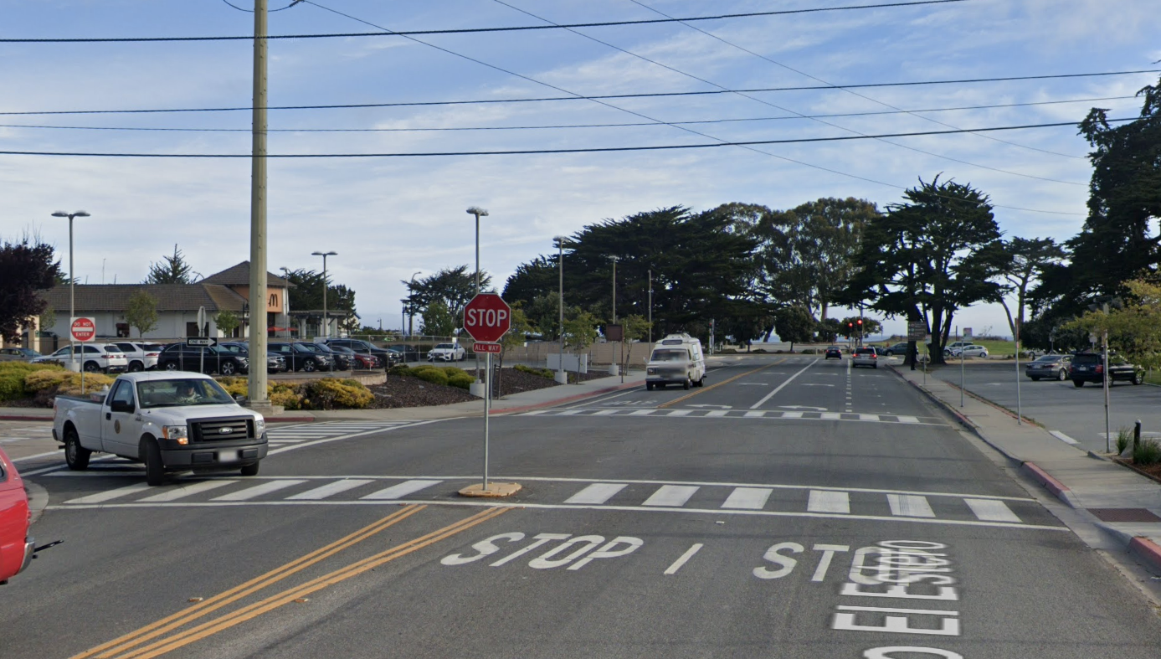

*Camino El Estero at Franklin St, Before Post Alerts 2021*

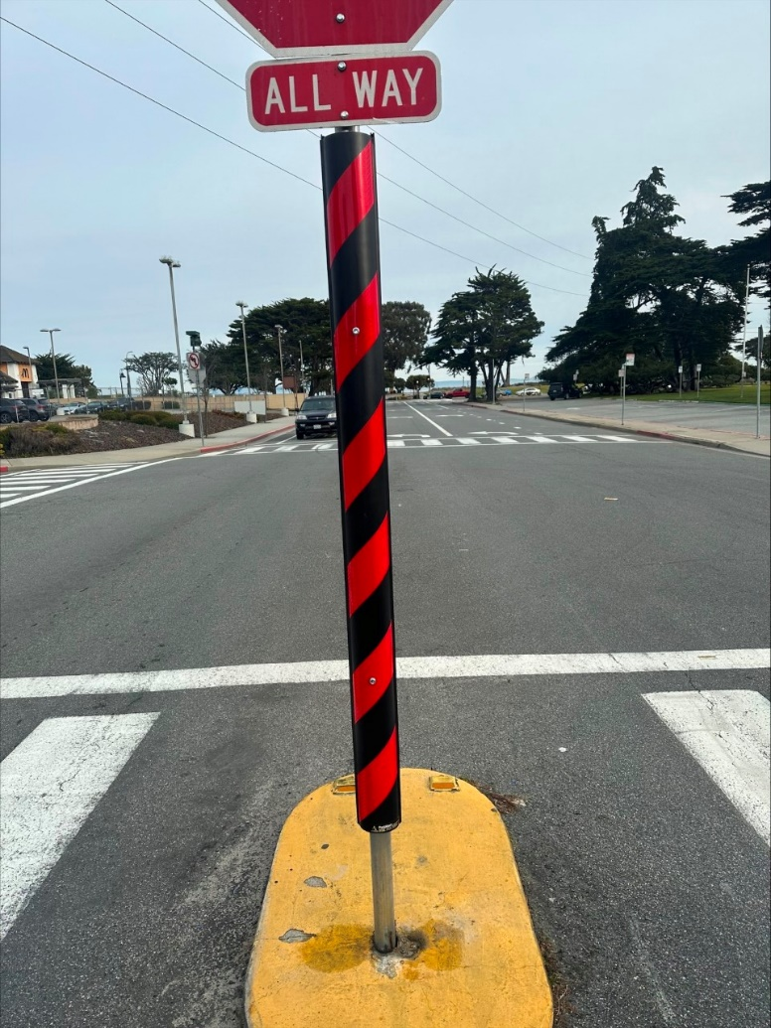

*Camino El Estero at Franklin St, After Post Alerts 2023*

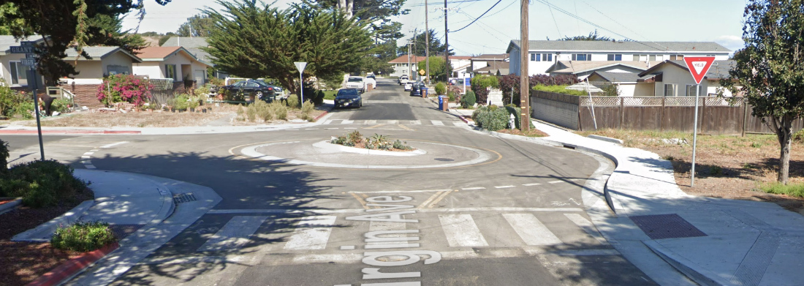

*Virgin Avenue Traffic Circle at Grant, Before Post Alerts 2017*

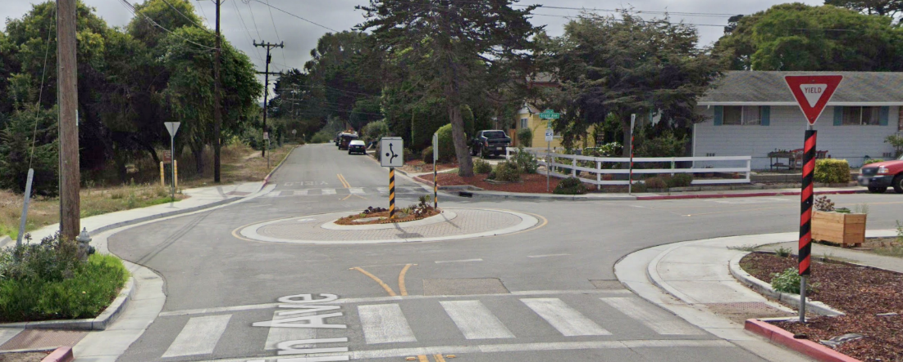

*Virgin Avenue Traffic Circle at Grant, After Post Alerts (Daytime) 2023*

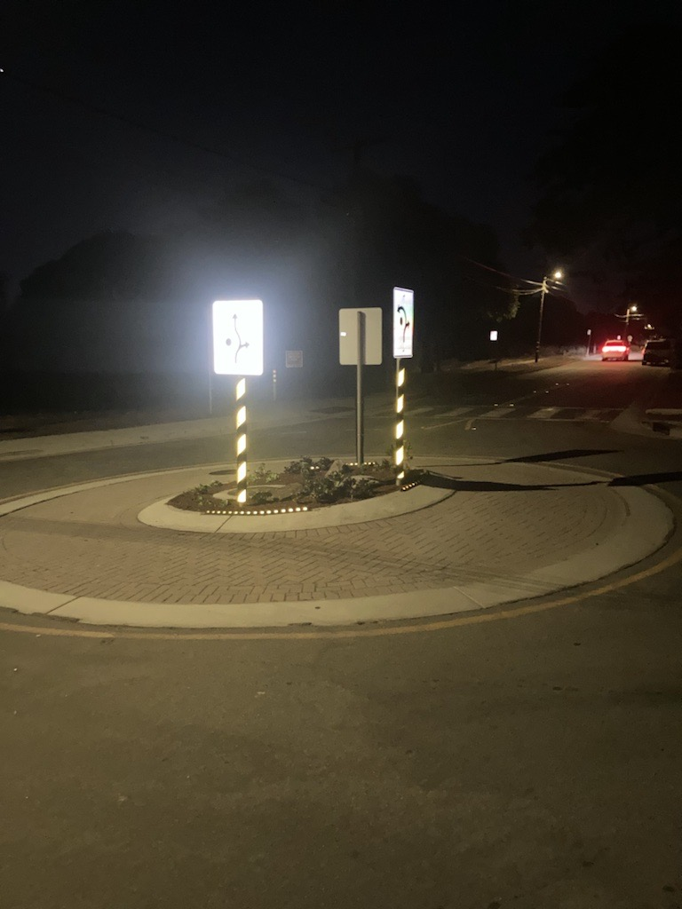 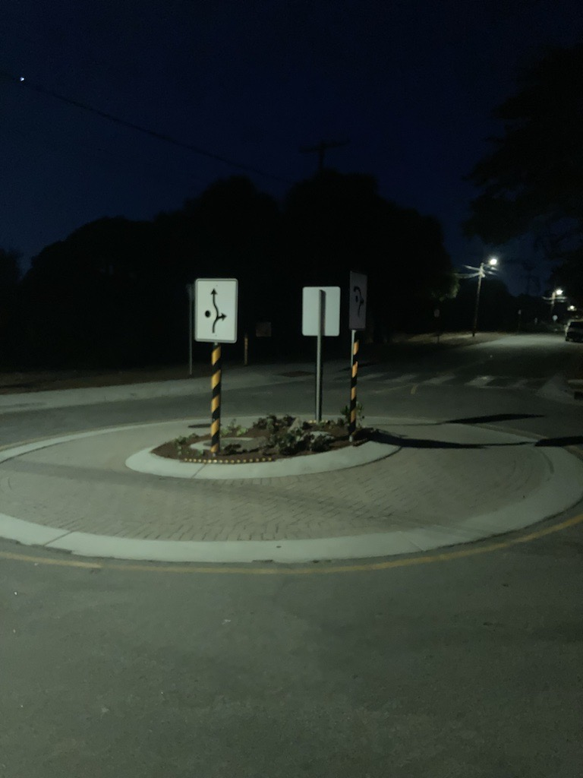*Virgin Avenue Traffic Circle at Grant, After Post Alerts (Nighttime) 2023*