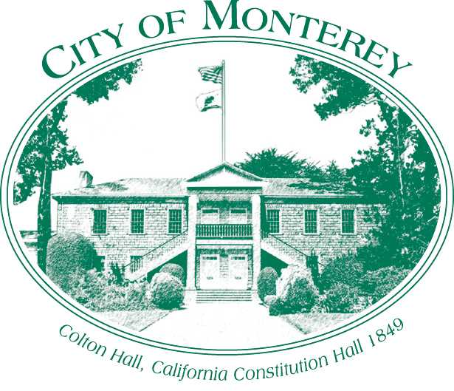

Measure X Project Report
December 2025
Measure X Transportation Projects
2024 Traffic Signal Inventory
This project is the prime example of using Measure X funding to support transportation safety and operations improvements to enhance the quality of Transportation in Monterey and Monterey County.

Project Description
The City of Monterey maintains 56 traffic signals, two additional signalized intersections are within the City of Monterey but owned and operated by Caltrans. Many of these traffic signals were installed over 30 years ago and with regular maintenance the original traffic signal components are still in use today.
This project is a comprehensive look at the City’s traffic signals and supporting infrastructure. Consultants inspected every traffic signal looking at the conditions of equipment such as the mast arms and traffic signal controllers.
The City will use the information from the Traffic Signal Inventory to strategically plan improvements and the replacement of traffic signal components.

Project Update
Consultants completed the inventory over 5 inspection days in May and June of 2024. Staff received the first draft of the inventory in August 2024 and the final memo in November 2024. City Staff has received a final memorandum and recommendations which were incorporated into the City's infrastructure presentation and recommendations for near-term, mid-term and long-term funding. Recommendations will be incorporated into maintenance and capital projects. An example of a future project, potentially funded by Measure X is a secondary phase of the Reflective Traffic Signal Backplates Project.

Project Funding
Account 1 (35c1850) (MEASURE X): $82,000.00
Total: $82,000.00

Photos
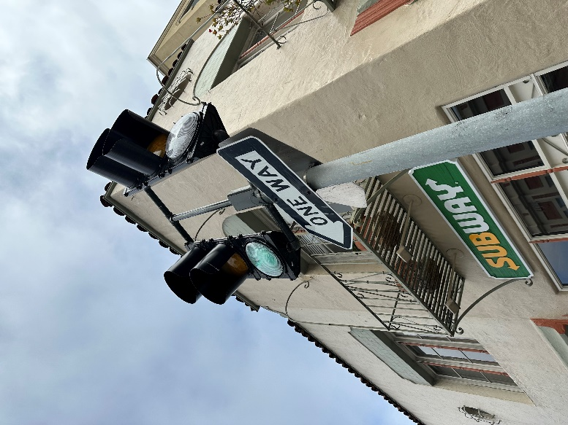
Traffic signal at Calle Principal and Franklin Street, missing visors for signal faces, 2024

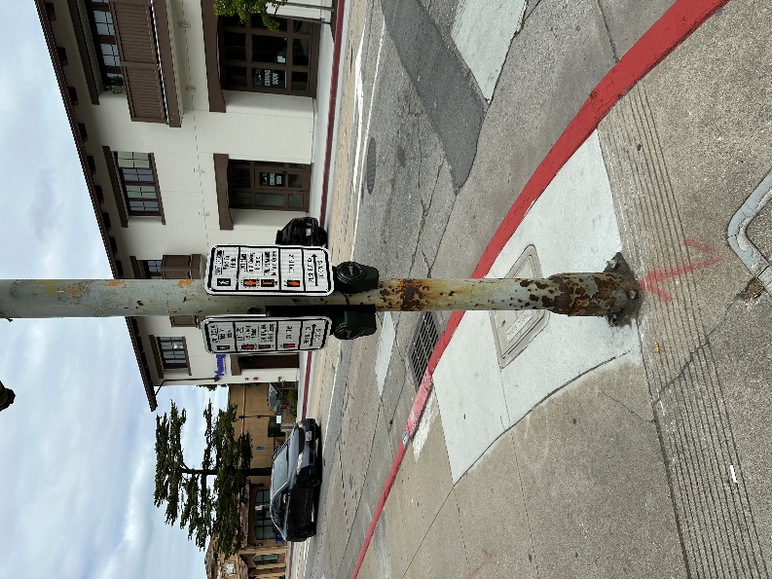
Traffic Signal pole, believed to be from last improvement project in 1972.

