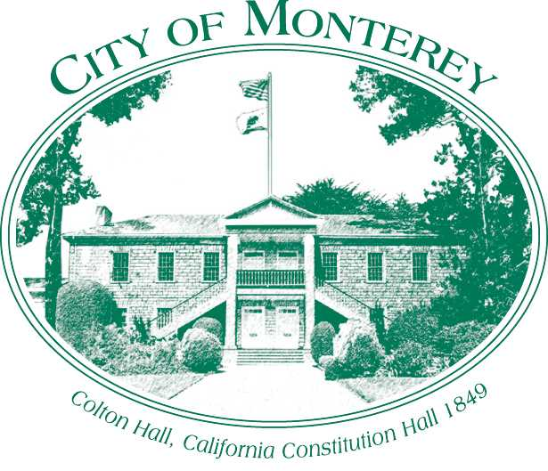

Measure X Project Report
December 2025
Measure X Transportation Projects
City of Monterey Crosswalk Policy
This project is the prime example of using Measure X funding to support transportation safety and active transportation improvements to enhance the quality of Transportation in Monterey and Monterey County.

Project Description
The City of Monterey routinely receives requests from residents to install crosswalk markings or enhance crosswalks. However, designing a safe roadway crossing for pedestrians is a complex process, and the installation of a marked crosswalk does not necessarily constitute a safe pedestrian crossing. The purpose of adopting a crosswalk policy is to provide the City with standard evaluation criteria, policies, and improvement types for existing and new pedestrian crossings. The evaluation criteria for existing crosswalks provides direction on whether they should be unmarked, marked, enhanced, or removed. The evaluation criteria for new crosswalks provides direction on whether the proposed location is suitable for a crosswalk. This policy document establishes a data-driven, transparent, and uniform process for considering the installation, enhancement, or removal of crosswalk markings that can be referenced when designing future safety improvement projects.

Project Update
In May 2025, City Council approved the new City of Monterey Crosswalk Policy. Staff has used it to evaluate existing and proposed crosswalks focusing on those affected by the upcoming capital projects for curb ramps and resurfacing projects.

Project Funding
Account 1 (CIP2012) (MEASURE X): $54,370.00
Total: $54,370.00

Photos
A copy of the crosswalk policy is available on the City website on the homepage of Traffic engineering.
https://monterey.gov/Document-Center/Departments/Public-Works/Engineering/Traffic-Engineering/City%20Council,%20Reso%20No%20%20%2025-052,%20Title%20%20%20Adopt%20Crosswalk%20Policy,%20Mtg%20Date%20%20%205-20-2025.pdf?t=202510131353350

