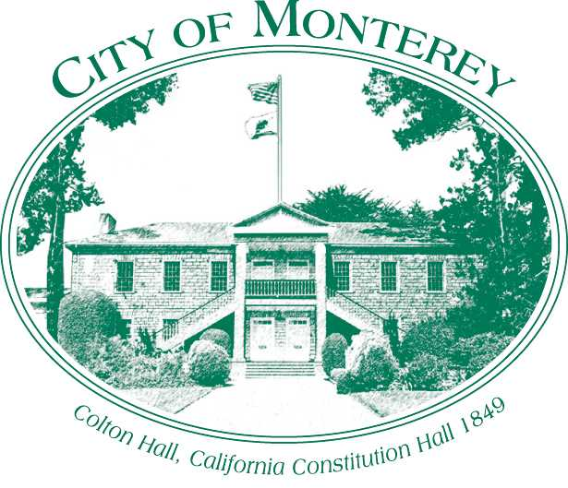

Measure X Project Report
December 2025

Measure X Citywide Traffic Signal Adaptive System
The City of Monterey experiences significant and unpredictable arterial roadway congestion, which creates inefficient traffic flow resulting in considerable emissions of pollutants and particulate matter. This degrades quality of life as well as air quality.
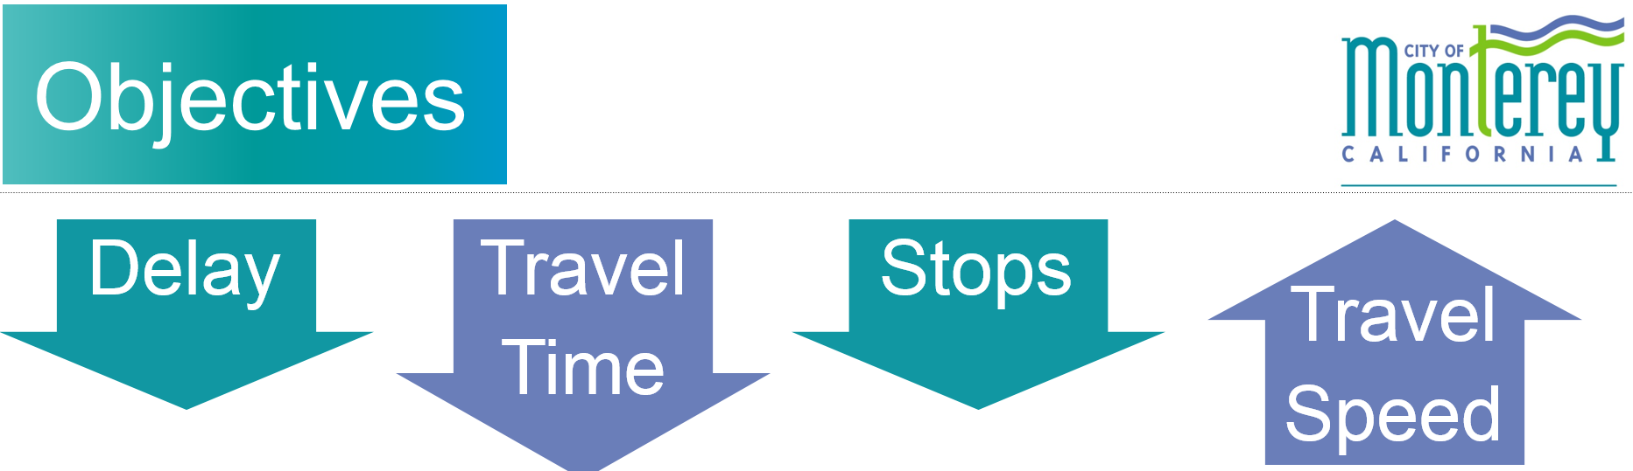
Adaptive traffic control systems are the latest technology for improving traffic conditions by better synchronizing and controlling traffic signals. The system uses vehicle detection and artificial intelligence software to respond accurately and immediately to real-time traffic conditions. This enables the system to use green light time efficiently and to progress traffic through a corridor with few or no stops, and therefore less fuel consumed and fewer emissions. By eliminating idling due to stops and the resulting acceleration, vehicles burn less fuel and expel fewer pollutants and particulate matter. There are also travel time, quality of life, economic, and safety benefits from the system. The system consists of installing additional video vehicle detection and in-cabinet processors as well as software and engineering services.

City of Monterey staff extensively researched the different adaptive systems and based on a study of 12 different systems, conducted by Kimley Horn and Associates, the City chose to deploy the SCOOT (Split Cycle Offset Optimization Technique) system.

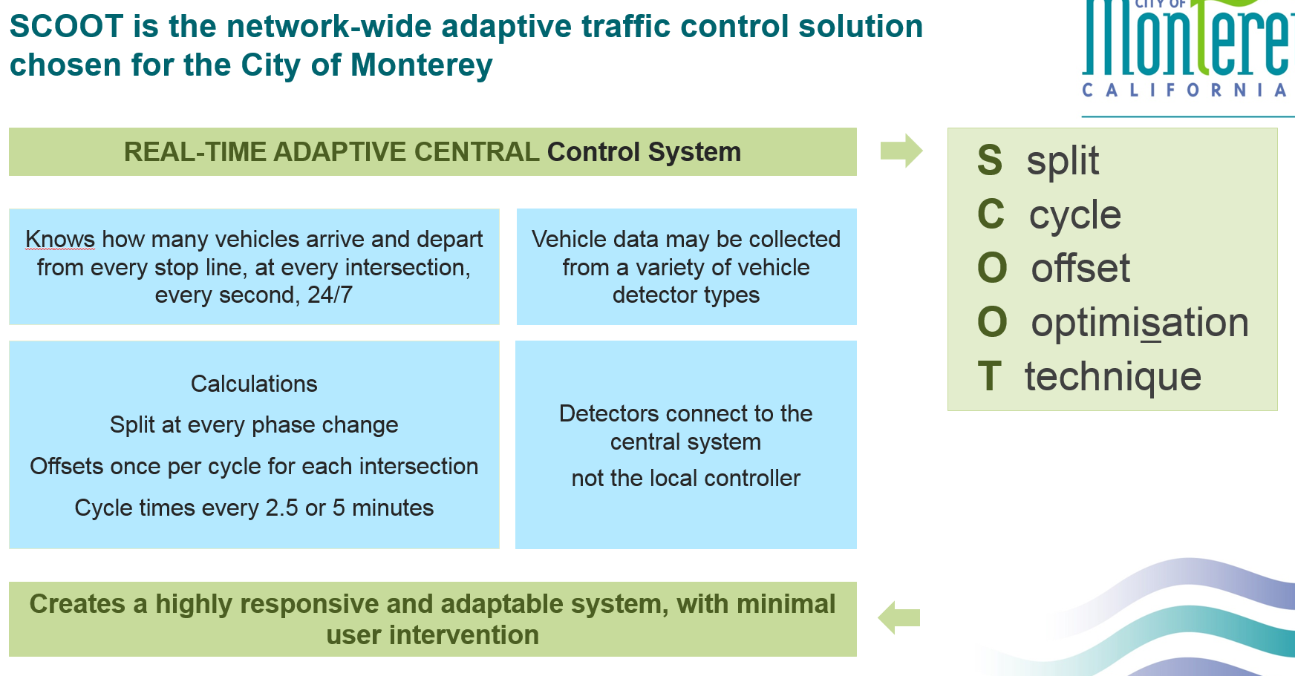

This ongoing project has been funded through Measure X, Monterey Bay Air Resources District’s Emissions reduction grant, City of Monterey Neighborhood Capital Improvement Program and Regional Surface Transportation Program. Staff has applied for competitive grants to fund all of these efforts. By combining multiple sources of funding and leveraging Measure X dollars, staff has been able to fund the system implementation resulting in cost and time savings. By managing this large project in house, the City has been able to efficiently implement necessary equipment upgrades, fiber optic communication installation and install the adaptive system. By eliminating mark-up costs and profit margins, staff estimates a cost savings of over $700,000 for this Citywide Project.
The system uses green time efficiently and progresses traffic through a corridor with few or no stops, and therefore less fuel consumed and fewer emissions. By eliminating idling due to stops and the resulting acceleration, vehicles burn less fuel and expel fewer pollutants and particulate matter. The system, when completed along Lighthouse, Del Monte and North Fremont, Munras, Foam, Pacific and Franklin, will result in a yearly reduction of 20 tons of criteria pollutants (NOx, ROG and PM).

Between 2016 and 2019, the following intersections were running adaptive control:

- Lighthouse and Reeside
- Lighthouse and Dickman
- Lighthouse and Drake
- Lighthouse and McClellan
- Lighthouse and Hoffman
- David and Hawthorne
- Lighthouse and David
- Lighthouse and Irving
- Lighthouse and Prescott
- Del Monte and Washington
- Del Monte and Figueroa
- Del Monte and Camino El Estero
- Del Monte and Camino Aguajito
- Del Monte and Sloat
- Del Monte and NPS
- Del Monte and Casa Verde
- Del Monte and English

In 2020, the North Fremont Corridor was completed:

- North Fremont and Casa Verde
- North Fremont and Airport/Dela Vina
- North Fremont and Ramona
- North Fremont and Casanova

In 2021, we also completed the installation of Scoot on the Munras/Fremont and Foam corridors:

- Munras and El Dorado
- Munras and Del Monte Center North
- Munras and Del Monte Center South
- Munras and Soledad
- Soledad and Pacific
- Fremont and Abrego
- Fremont and Camino El Estero
- Foam and Cannery Row
- Foam and Reeside
- Foam and Drake
- Foam and Hoffman
- Foam and Prescott
- Foam and Irving
- Foam and David

The City is has installed video detection equipment and activated fiber communication to the corridor. The implementation of the Adaptive Signal System on the Pacific corridor is anticipated to start in January 2023:

- Pacific and Franklin
- Pacific and Jefferson
- Pacific and Madison
- Pacific and El Dorado/Martin

The City has been working to resolve communication issues with two signals that were on the Munras and Pacific Corridor, the City also due to the success of the Pacific and Del Monte Corridor is planning to expand the Del Monte Corridor in February 2024:

- Pacific and Scott
- Munras and Webster
- Del Monte and Tyler
- Del Monte and Alvarado
- Del Monte and Calle Principal

The City is preparing to install the Adaptive Signal System on the Franklin corridor starting in September 2027, after infrastructure improvements:

- Franklin and Van Buren
- Franklin and Calle Principal
- Franklin and Alvarado
- Franklin and Tyler
- Franklin and Washington

In September 2025, the City hosted an all-day training with Western Systems and Yunex the distributor of the SCOOT software. The training was attended by the City of Salinas who also uses the SCOOT software.
In order to implement the SCOOT system at additional intersections, existing traffic signal equipment has and will have to be upgraded (cabinets, controllers and communications) and new vehicle detection will need to be installed. Measure X funding was used to upgrade outdated and failing equipment to improve the reliability of the City’s traffic signal system.

The SCOOT system also is completely compatible with the SIEMENS TACTICS central system that the City of Monterey uses to manage their signal system.

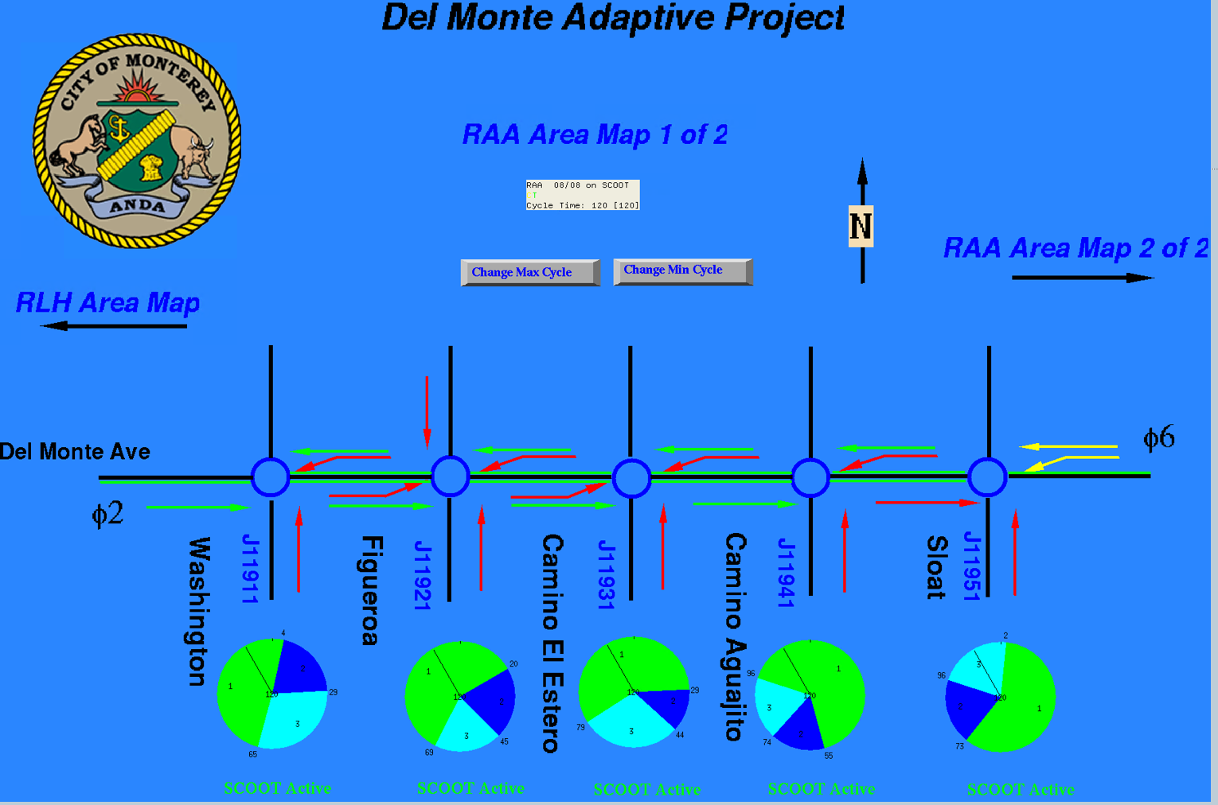

SCOOT requires both software and hardware asset installation and construction and the project included such assets as:

- Video detection on all approaches of all eight intersections
- Cabinet upgrades
- Controller and/or software (SEPAC 5.0) upgrades
- SCOOT expansion licenses
- Urban Traffic Control database programming
- SCOOT database programming
- SCOOT Communication Server programming
- Calibration, Validation and Fine tuning of the adaptive model

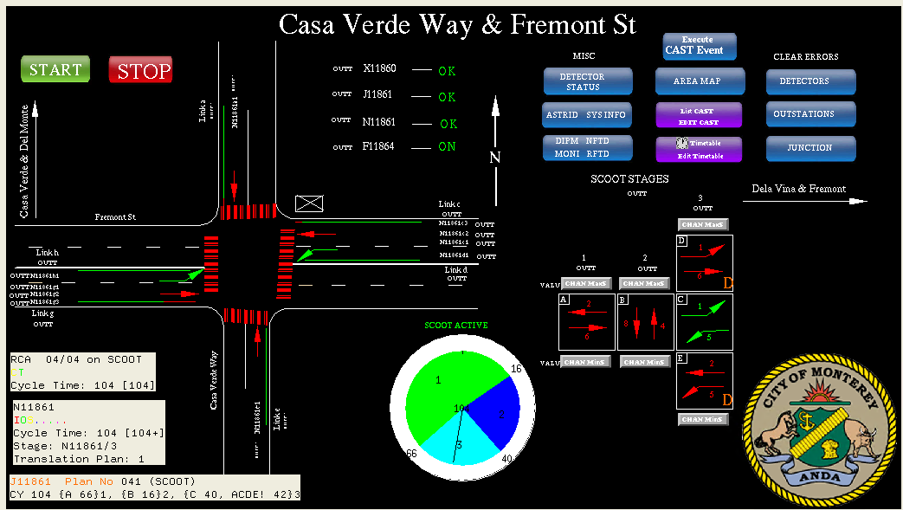

Coordinated traffic signals on the corridor will benefit all modes of travel by improving traffic flow and maintaining more consistent travel speeds. MST has a BRT service on Lighthouse and North Fremont that will also greatly benefit from this project and offer a substantial savings for bus travel, improving the ability for travelers to reach the corridor on modes other than via automobile. This system will also benefit the future SURF line on Del Monte Avenue.

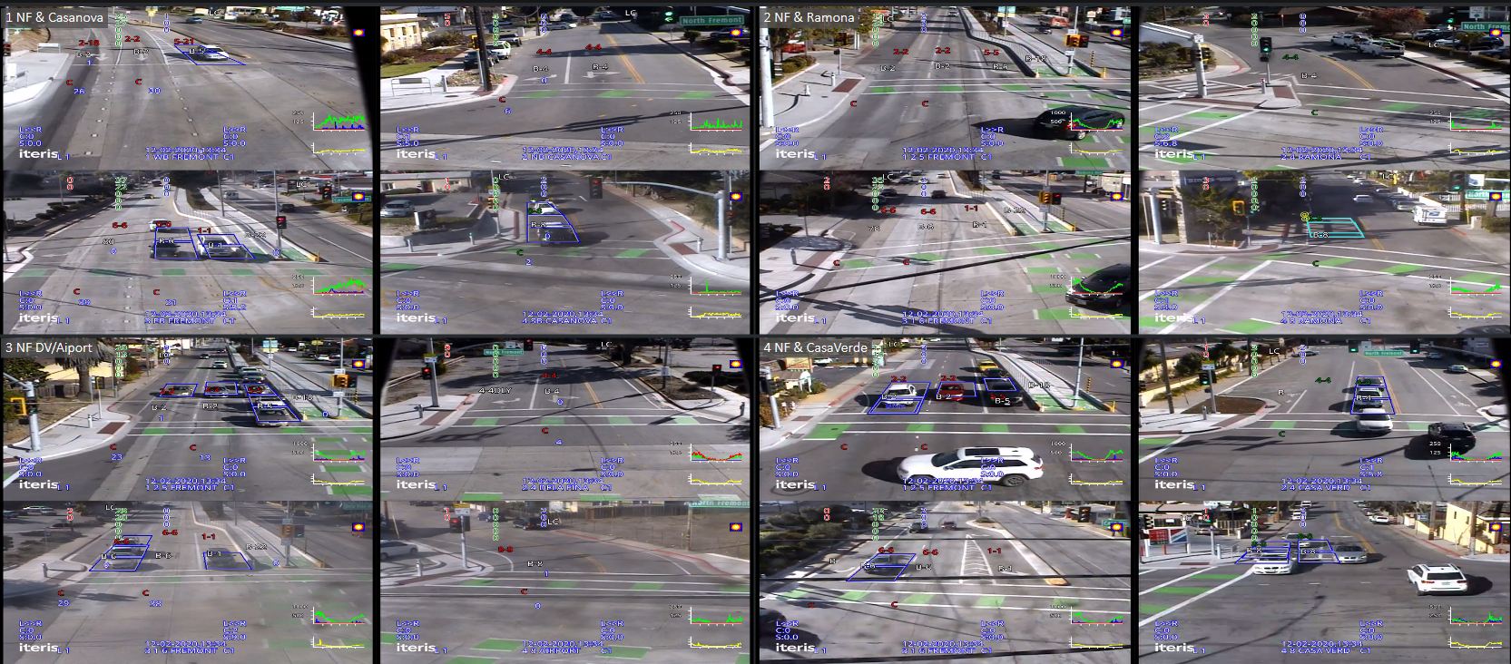
  - New Video detection on N Fremont

The City of Monterey has been so successful in installing the adaptive system in a cost-effective and efficient manner that we received yet another grant from the Monterey Bay Air District in the amount of $382,000 to implement the same system on the Foam and Munras corridors. And in 2021, the City applied for and received another AB2766 Grant in the amount of $400,000 for Pacific and Franklin.

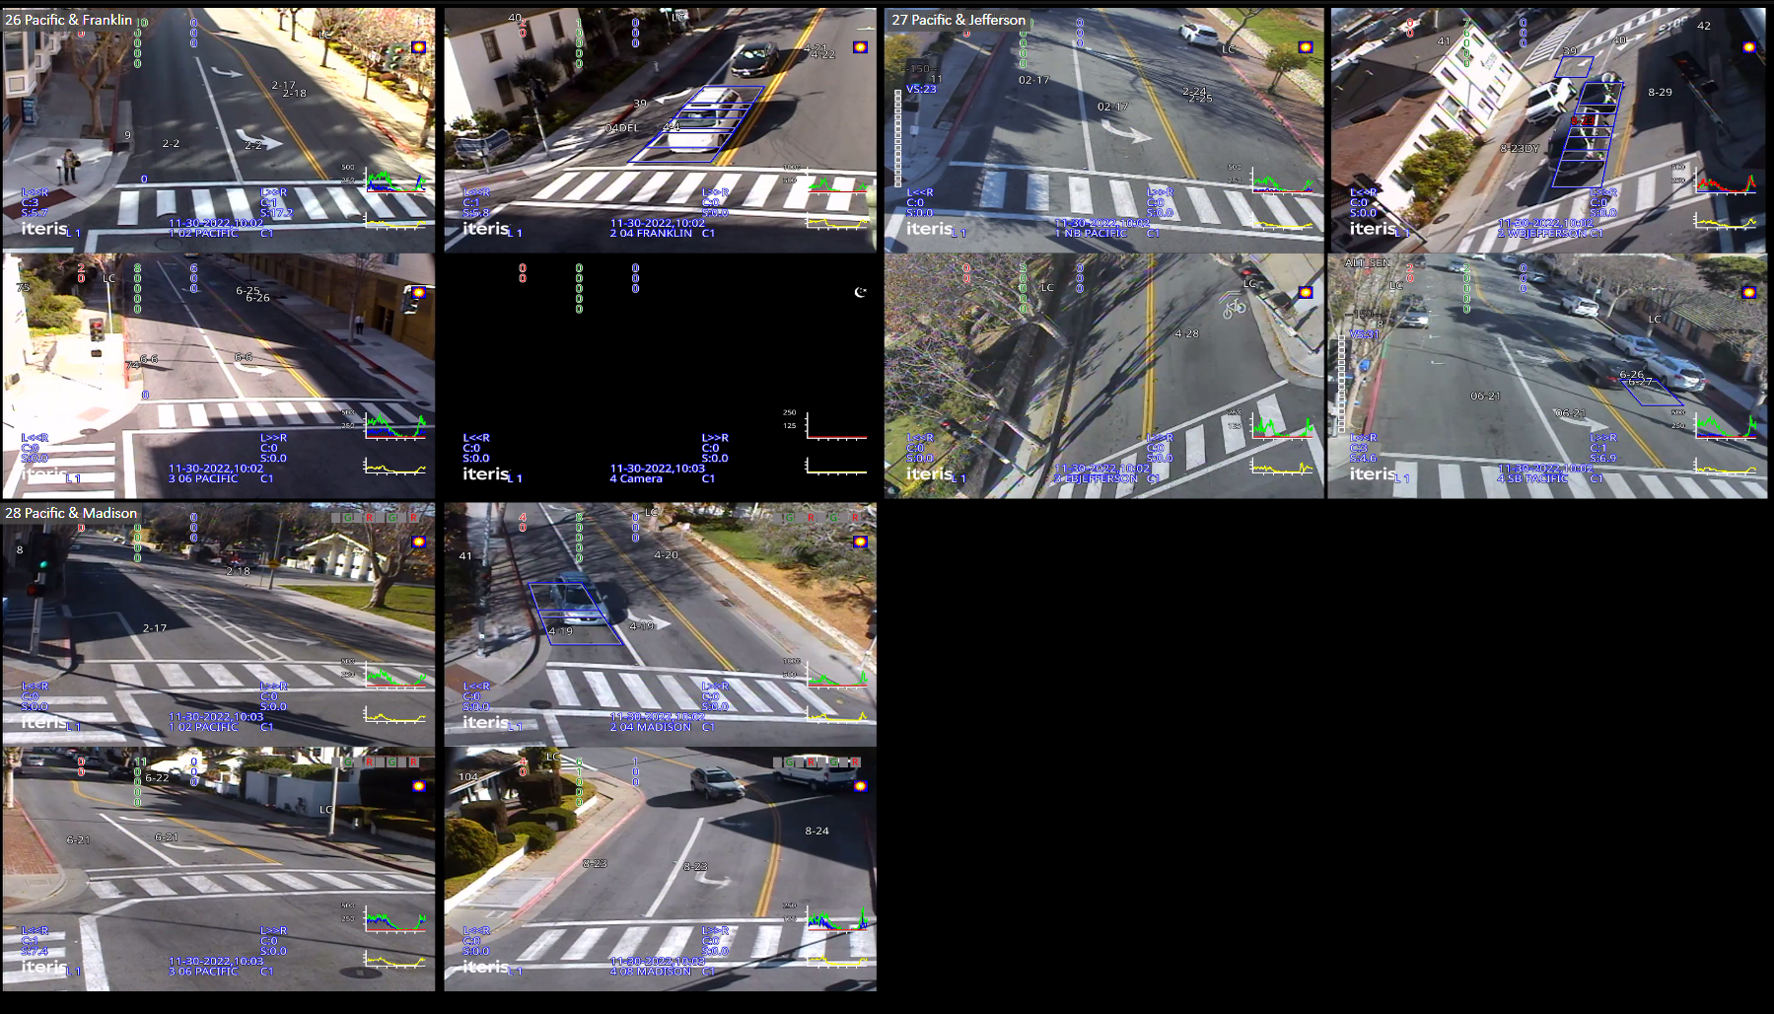
  - New Video detection on Pacific

The Franklin Corridor will also require substantial upgrades and entirely new communication infrastructure due to its age. The City has been developing a plan to strategically bring communication prior to implementing the Adaptive Signal System to the half-mile long corridor.

Although not Measure X funded, the Citywide Signalized Intersection ADA Upgrades Phase 3A Project which includes the intersection of Franklin & Tyler and Franklin & Washington is expected to start in January 2025. This project will provide the necessary underground communication facilities for the two intersections on Franklin. Phase 3B which included Franklin & Calle Principal and Franklin & Alvarado are expected to be completed in late 2025. Upon the completion of Phase 3B, all the underground infrastructure will be in place for the Franklin SCOOT corridor.

Results from the prior studies on Lighthouse, Del Monte, North Fremont, Foam, Munras, and Pacific revealed the following data:

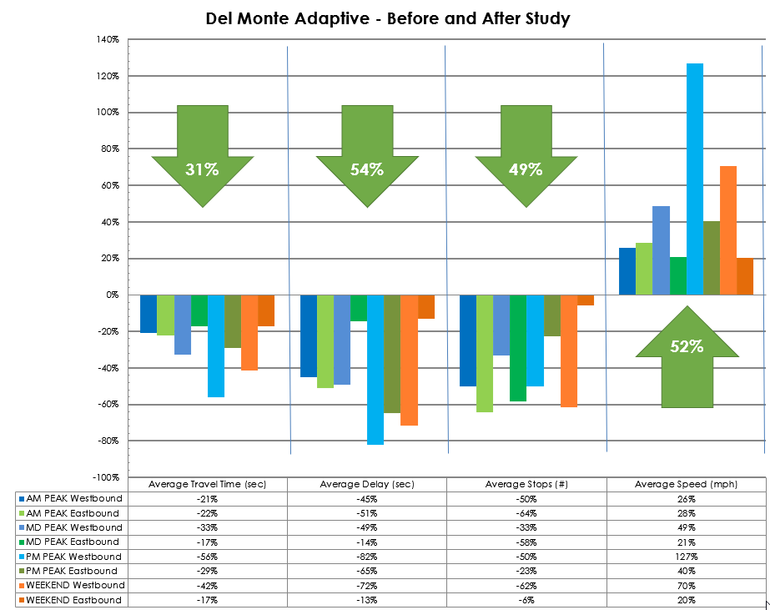

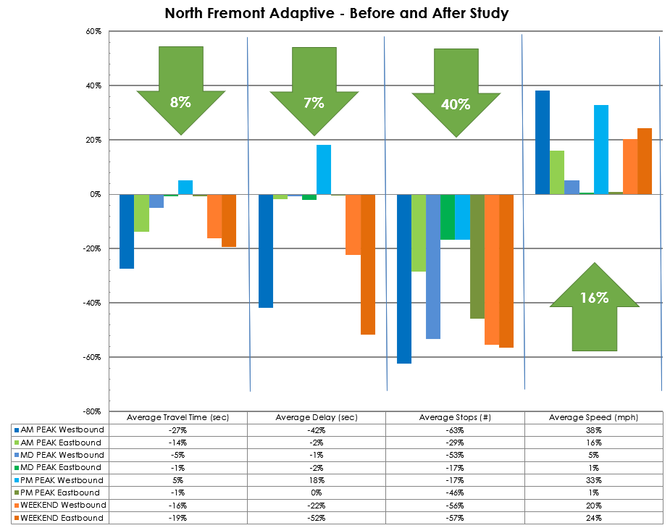

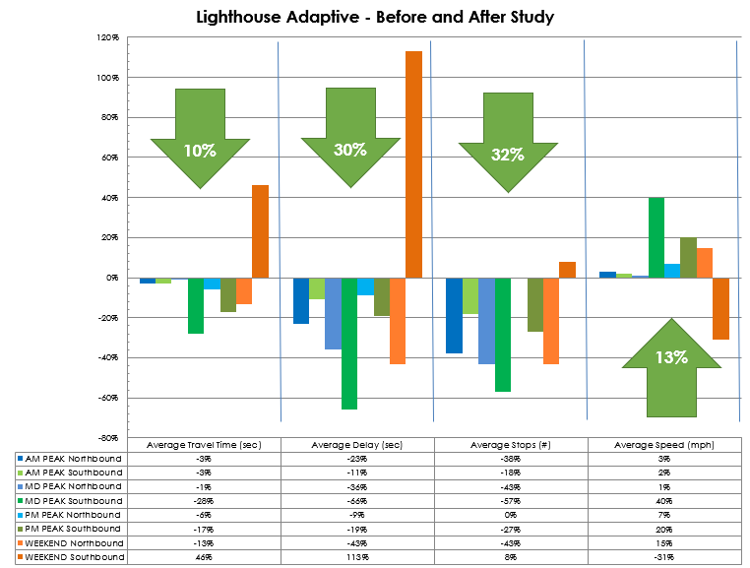
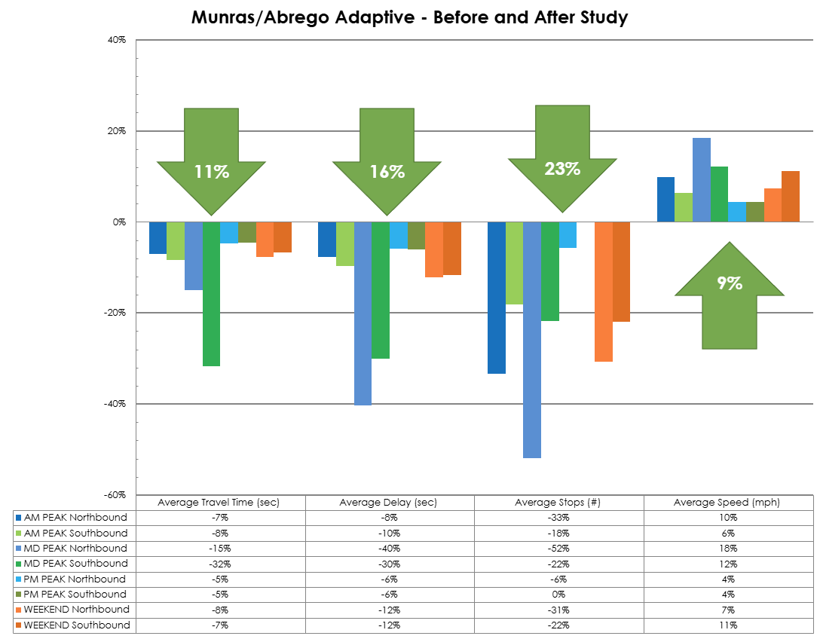

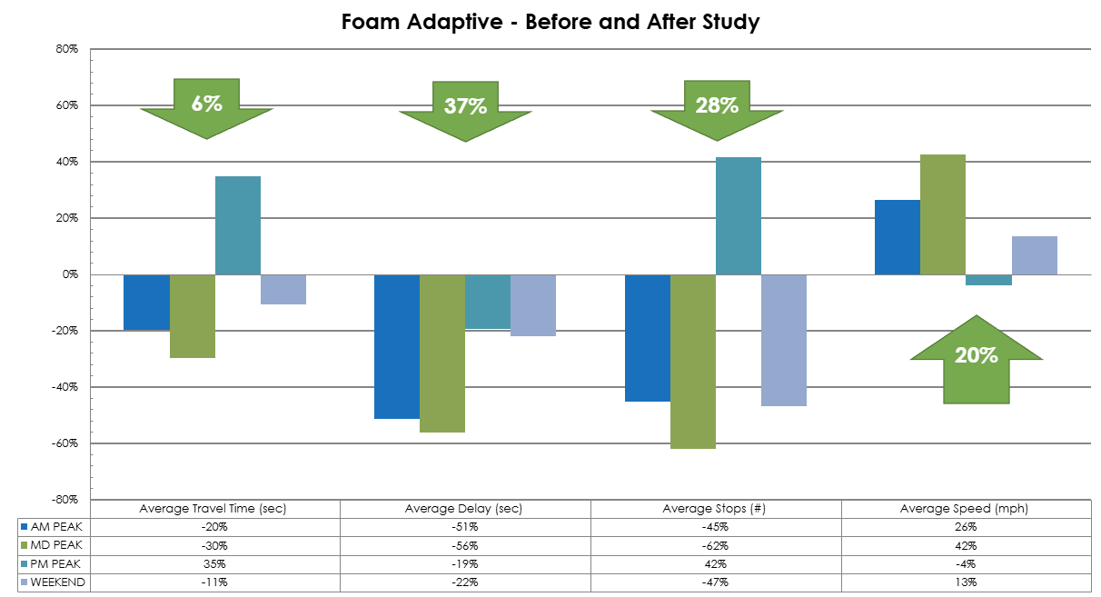

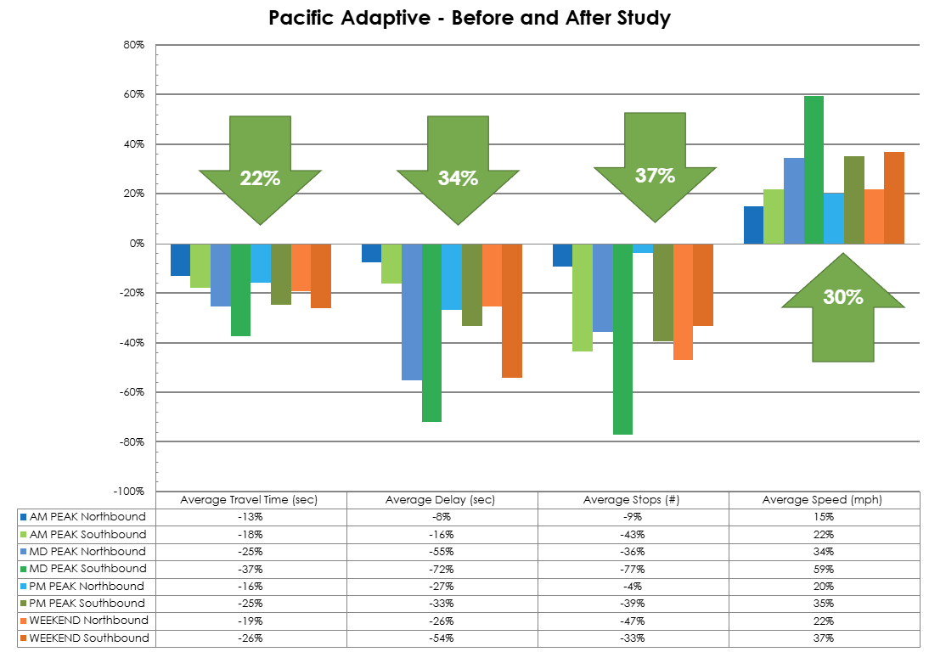

For the purposes of the AB2766 Air District grant, the City calculated the average annual time savings, fuel savings, and CO₂ reductions. These are averages based on weekdays when SCOOT is active and does not include the savings on weekends or when SCOOT is turned off.

Corridor | Veh- Hr travel time savings per year (veh-hrs) | Avg Fuel Consumption per year  (gallons) | Average CO₂ reduction from travel time savings  (Metric Tons)
Pacific St | 24,469 | 6,345 | 58
Foam St | 6,724 | 1,775 | 16
Munras Ave | 44,594 | 11,773 | 108
Del Monte Ave | 306,404 | 83,771 | 770
Fremont St | 11,579 | 3,329 | 31
Lighthouse Ave | 71,623 | 18,572 | 170

Project Funding

Implementation Project
Account 1 (37C2050)(MEASURE X): $159,668.63
Account 2 (NIP2050)(NCIP): $100,000.00
Account 3 (CIP2011)(AB2766): $382,032.00
Account 4 (CIP2101)(RSTP): $1,802,625.61
Account 5 (CIP2112)(AB2766): $400,000.00
Total: $2,844,326.24

Before & After Studies
Foam & Munras $46,399.50
Pacific Street $38,200.00

Additional Adjustments
SCOOT Plan Sheets & Rephasing $6,683.75

