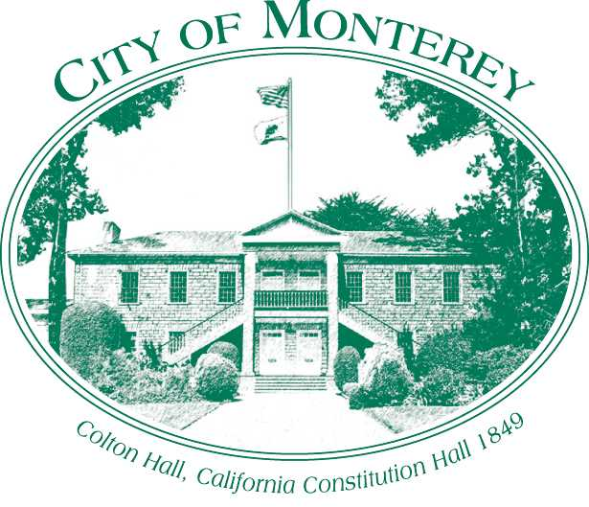

Measure X Project Report
December 2025

Measure X Transportation Projects
RSTP Grant Application for Madison/Hermann/Larkin Intersection Safety Improvement Project
This project is using Measure X funding in combination with other Grant Programs such as the Regional Surface Transportation Program (RSTP) to enhance transportation safety.

Project Description
This grant cycle TAMC established a new Quick-Build Pilot Program. The goal of the QuickBuild Pilot Program is to provide funding to local jurisdictions for interim capital improvement projects. These projects require minor construction activities and are typically built with durable, low to moderate cost materials, and last from one year to five years. The purpose of a quickbuild project is to immediately implement safety needs or improve non-motorized user comfort, allowing a community to benefit quickly from improvements made, and/or allow the people of a community affected by the project to provide input and test the project improvements before they are permanently constructed.
The City developed an application and the intersection of Madison Street, Hermann Drive, and Larkin Street was identified as a good candidate for the grant program due to the proximity of Monterey High School. The City’s application requested funds for the Madison/Hermann/Larkin Intersection Improvements. The project includes the installation of a painted island at an existing 5-leg all-way stop control intersection. The central island will be painted, and the legs will be restriped to provide striped splitter islands. Temporary vertical elements such as modular medians, or lane separators will be installed on intersection approaches to narrow the travel lanes and reduce traffic speed. The TAMC Board of Directors approved funding for FY23-24 cycle of Regional Transportation Program funding, including funding for the Madison/Herrmann/Larkin Intersection Safety Improvement Project on August 23, 2023, in the amount of $119,120.

Project Updates
The City of Monterey has finished the design and worked with an on-call contractor for the pricing of the project. The on-call pricing came significantly above the engineer's estimate so the City is looking at formally bidding the project for competitive pricing. In September 2025, the City received an additional $130,000 for the project and is working to bid the project early 2026.

Project Funding
Account 1 (35C1851) (MEASURE X): $29,800.00
Account 2 (CIP2422) (RSTP Quick Build): $119,120.00
Total: $148,920.00

Before & After Photos
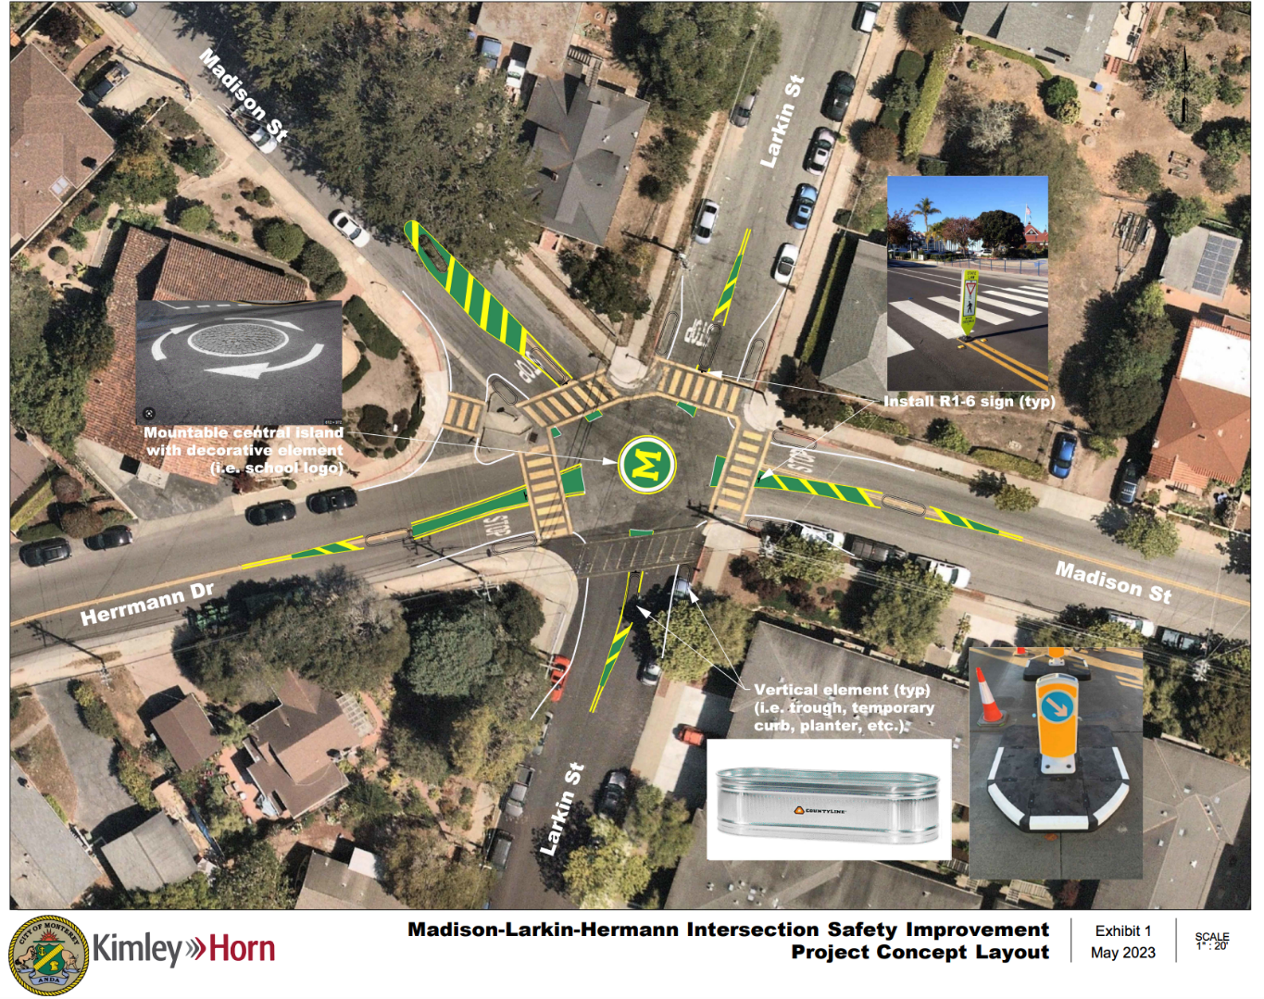
Preliminary Concept for the Intersection Improvement, 2023
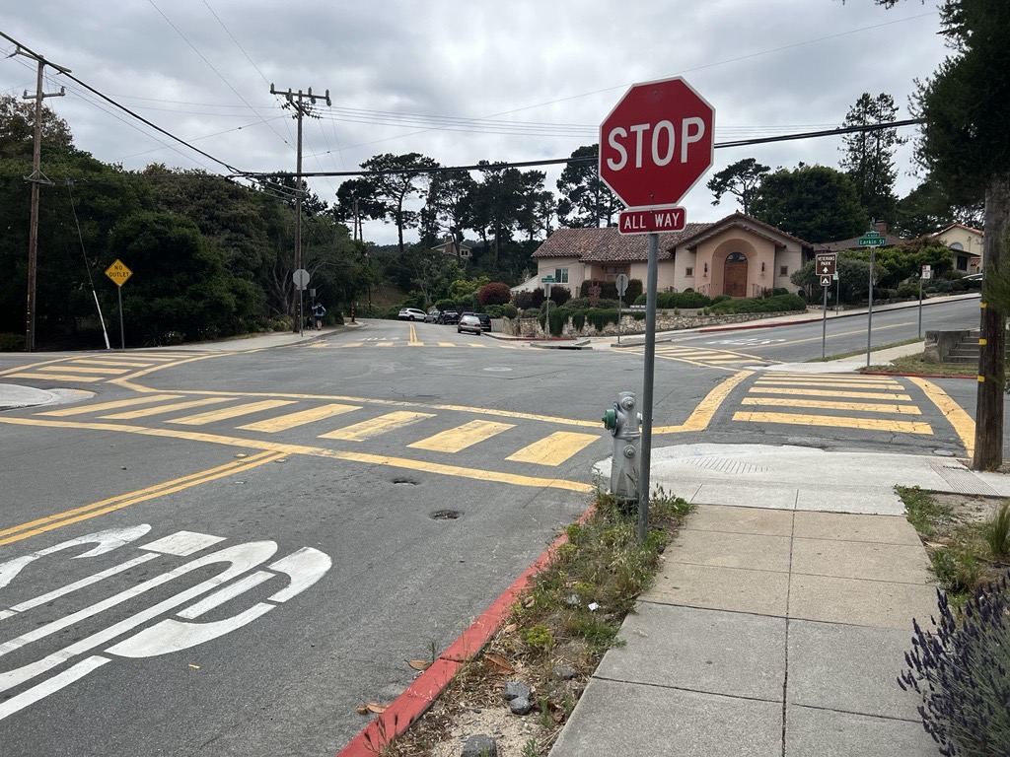
Before, 2023

