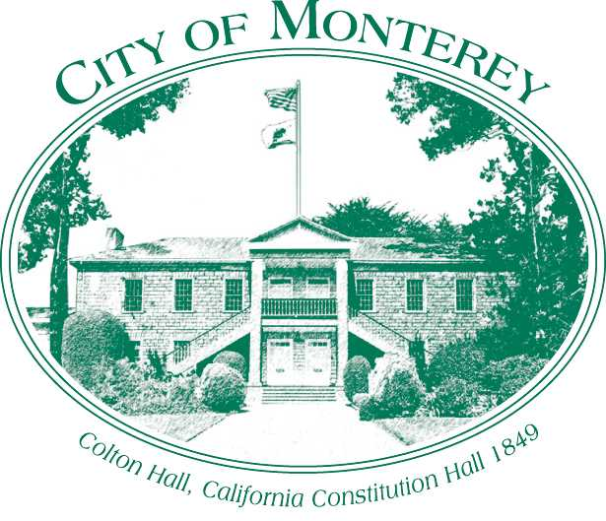

Measure X Project Report
December 2025

Measure X Transportation Projects
Grant Application for Mark Thomas/ Garden/Fairground/ Sloat Bicycle and Pedestrian Improvement Project
This project is using Measure X funding in combination with the other funding sources including grant funding and local special funding, such as the Neighborhood and Community Improvement Program (NCIP). to enhance transportation safety.

Project Description
After the completion of the Class IV Median Bicycle Lanes on North Street as part of the North Fremont Bicycle and Pedestrian Access and Safety Improvement Project, the City started working towards the next expansion of bicycle connections from Median Bike Lanes. In 2019, the City started working toward the “North Fremont Gap Project” on the east end and in 2023 started working towards expanding the project on the west end.
This connection first identified in the City’s Multimodal Plan was to connect the bicycle lanes to the Recreation Trail via Casa Verde Way to Fairground Rd to Mark Thomas Dr to Sloat Ave. This connection provides an alternative route to the Recreation trail and connects multiple neighborhoods as well as major employers/educational centers. Another identified connection was to connect Garden Road, which has been identified as a housing opportunity site, to Fairground Rd.
City Staff started this grant application process in April 2023, while at the same time the City started to further develop concepts for a Neighborhood and Community Improvement Project, which was submitted for the FY22-23 cycle. This proposed NCIP project would cover the design and environmental phase for implementing bicycle and pedestrian improvements from Casa Verde Way to Fairground Rd to Mark Thomas Dr to Sloat Ave but excluded the Garden Road segment. In June 2023, the NCIP committee voted to prioritize projects for funding and this proposed project was ranked 3rd out of 95 projects.

Project Update
In October 2023, City Council authorized staff to move forward with the NCIP Project. To maximize the use of Measure X funds for grant opportunities, City staff is splitting the projects and moving forward with the Garden Road Project using Measure X funding to develop concepts and prepare for a future grant application, including an ATP grant application. The Casa Verde Way to Fairground Rd to Mark Thomas Dr to Sloat Ave segment will move ahead as an NCIP project and the City released a request for proposals for the Study, Preliminary Design and Environmental Document in April 2024, and received proposal May 2024. The City awarded the contract for this proposal to BKF Engineers in October 2024.
Staff kicked off the project in early 2025 and the consultant has provided preliminary concepts to the City for review. City Staff presented concepts to the public for comment on Parking Day (September 19, 2025). As with the El Estero Bike Path Project, the Garden Road Project, and the East Franklin Project, Staff is planning to do combined outreach to receive feedback and provide updates on active transportation projects.

Project Funding
Account 1 (35c1851) (Measure X): $11,809.90
Account 2 (ncp2404) (NCIP): $700,000.00
Total: $711,809.90

Before & After Photos
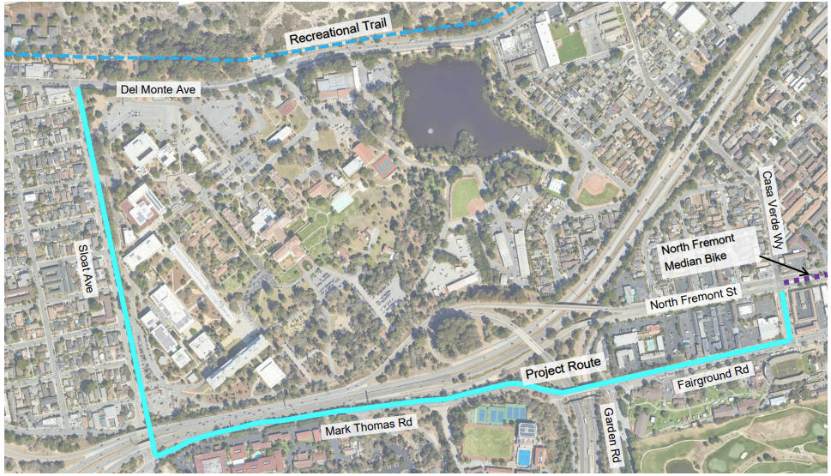
Project Area Map

