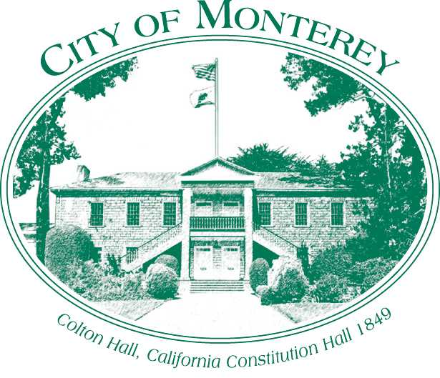

Measure X Project Report
December 2025
Measure X Transportation Projects
Lake El Estero Multi Use Path
This project is the prime example of using Measure X funding to support transportation safety and active transportation improvements to enhance the quality of Transportation in Monterey and Monterey County.

Project Description
This project proposes a Class I multi-use path around the perimeter of Lake El Estero and El Estero Park Complex, which incorporates El Estero Dog Park, Dennis the Menace Playground, Sollecito Ballpark, the Skatepark and El Estero Park Center which functions as a community center. The scope includes closing sidewalk gaps with new AC sections and upgrading existing dirt paths to have a continuous class I facility around the lake. The scope will also include pedestrian crossing improvements at Del Monte Ave between the Rec Trail and the new multi-use path. This project started with a project on the Move Monterey Multimodal Plan, extending on the recreational trail connection project and Measure P/S ADA signalized intersection upgrades project.

Project Update
The City has prepared preliminary concepts. Staff is working on adding this project to Move Monterey the City’s Multimodal Plan Project List including public outreach.

Project Funding
Account 1 (CIP2509) (MEASURE X): $200,000.00
Total: $200,000.00

Photos
N/A, will provide photos with developed outreach materials.

